Circular 通告 (15)

Safety Measures on Electricity Supply, Fair System & Furniture
有關電力供應、攤位結構及傢俱之安全措施

Electricity Supply電力供應
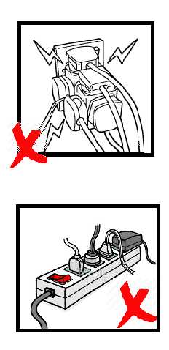 | Exhibitor should check which type of socket you have ordered including those standard socket included in the booth provided by organizer (if any) and its power limitation. Each socket can connect one electrical appliance only. The fuse will be broken if electricity consumption exceeds the power supply limit. HKD50 will be charged for each fuse re-installation. No multi-plug or extension cord are allowed to be connected to the socket. HKTDC reserves the right to suspend the electricity supply until the problem is rectified by the exhibitor concerned.  參展商請留意閣下所租用或大會提供(如包括)之電力插座供電量，每一個插座均有其負電上限，以及只供單一電噐使用，切勿超過負荷，以免保險絲斷路。現場重新安裝保險絲的費用為港幣五十元。參展商切勿於插座上安裝萬能插頭或拖板，一經發現本局將保留終止供電權利直至有關參展商將問題插座改正。
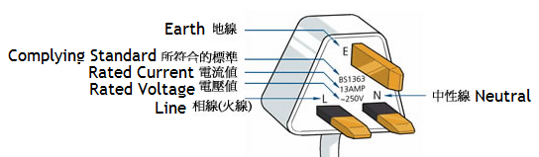 | The electrical appliance used by the exhibitor on-site should be a 3-pin plug and in compliance with the electrical safety requirements (as shown in the picture).  參展商所用之電器用品必須使用符合電力安全規格的三腳插頭(如圖示)。
 | For those exhibitors who ordered lighting connections only, please contact the “Technical Services Counter” for power supply once your lightings are installed. The exhibitors shall be solely responsible for any consequences caused by the electrical appliances they bring to the fair. Please do not exceed the power supply limit.  參展商若已租用電力接線服務（供自行攜帶及安裝電燈使用），在自行安裝電燈後，請聯絡會場之“攤位設施服務台”以便安排電力接駁。參展商將對自行攜帶之電器用品所引致之任何結果負擔所有責任，切勿超過負荷。
Fair System & Furniture攤位結構及傢俱
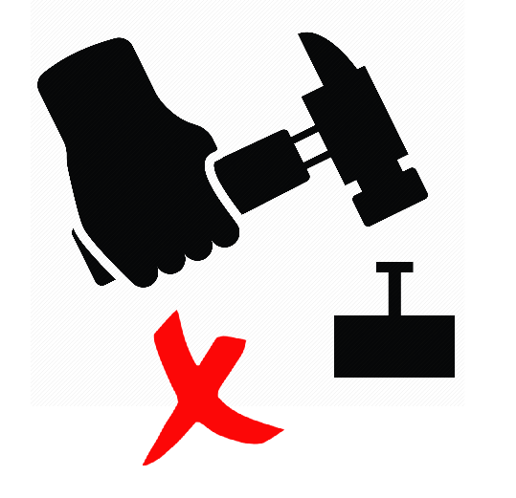 | No tapes, nails, fixtures, removals or modifications of any kind are allowed to be applied to the official booth structure. No additional booth fitting (including exhibitor’s own shelves), structure, lighting, display, decoration items or exhibits can be attached, by any means, to the aluminium profile or structure or panels or fascia of the booth. Please request for booth modifications at our Technical Services Counter ONLY. Exhibitors are liable to any damage caused to their booth fixtures and fittings at the fair.  攤位結構不得擅自作任何形式之拆除、改裝或張貼任何東西，亦不得釘上任何釘子。展台的鋁架或結構或圍板或公司名牌上均不能以任何方式附加任何額外的展台裝置(包括自攜層架)、結構、燈具、陳列品、裝飾物或展品等。如需作出改動，請於攤位設施服務台作現場申請。展覽攤位及展場內裝置如有任何損壞概由參展商負責賠償。
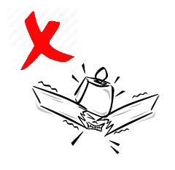 | Each square metre of wooden shelf and cabinet top can only support weight under 3kg. Hanging objects from ceiling beams and system panels are prohibited. For safety reasons, standing on the table, chairs, cabinet tops or showcase tops, etc. are strictly prohibited.  每米木層板及地櫃櫃面只能負重不超過三公斤之物件。天花橫樑及攤位圍板嚴禁懸掛任何物件。  基於安全理由, 嚴禁站立在桌子、椅子、地櫃或展示櫃等上。
The exhibitor undertakes to indemnify the organizer from any claims caused by their decoration / construction works done to the shell scheme. 參展商保證，對於任何因其或其聘用之承建商於展台施工或佈置而引致的索償，主辦機構毋須負責。
The exhibitor is recommended to take out insurance policies to cover itself against all potential liabilities. The exhibitor shall be solely responsible for death, injury, damages or any consequences in relation to the violation of any of the above guidelines.
建議參展商須就可能對其構成的所有潛在責任購買保險. 若違反以上任何指引，參展商將對引致之死亡、人身傷害、損失或任何後果擔負所有責任。
ES Onsite Circular – V4.1

